Model of a stiffened pressure vessel with a vacuum resulting in an external pressure of 100,000 Pa. End closure is 0.0508 m thick, shell 0.3492, frames are 0.5 m high, 0.127 m thick and space 1 m apart. Quarter symmetry, mesh is 10 m long, radius of end closure is 5 m.

Use shell model and solid elements

Elmer , shellsolver, stresssolver

feenox, solid elements

CalculiX, solid, and shell model

ABAQUS, shell Model

Table of results after images

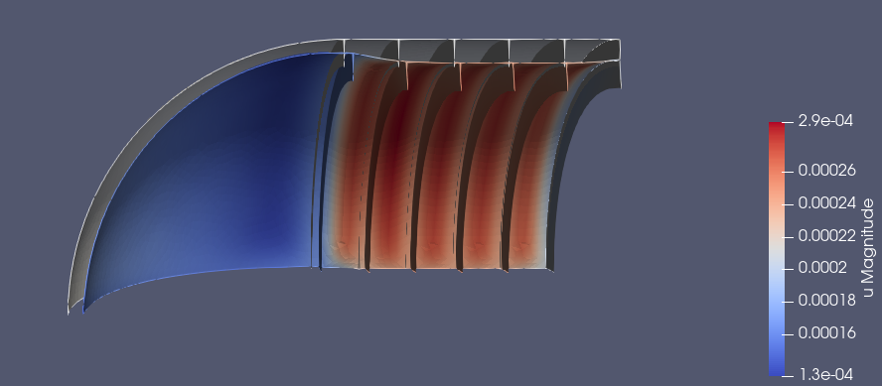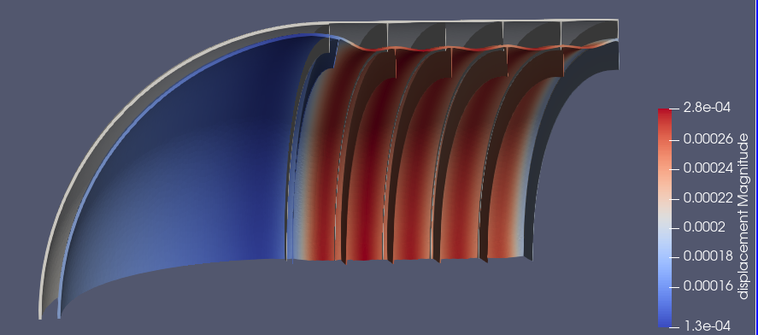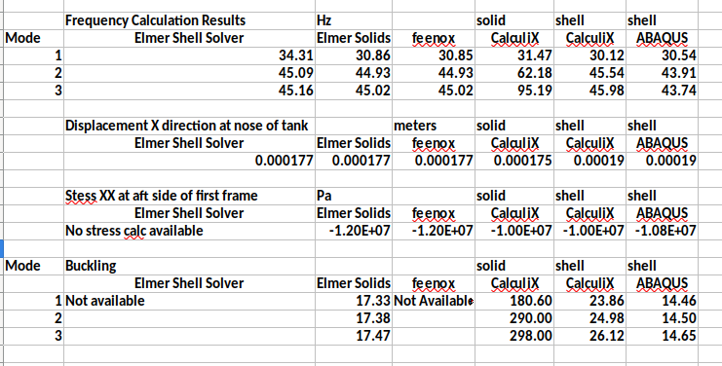

Displacements and stresses seem consistent across the solvers.

Buckling looks on par except for the CalculiX solid element model

Frequency looks consistent across feenox, CalculiX shell, and ABAQUS shell